Select Name, Gender, DepartmentName

from Doctors

left join Departments

on Doctors.DoctorID = Departments.DepartmentID

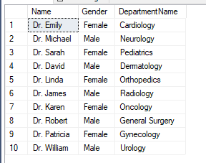

Select Name, Gender, Condition, WardName

from Patients

right join Wards

on Patients.PatientID = Wards.WardID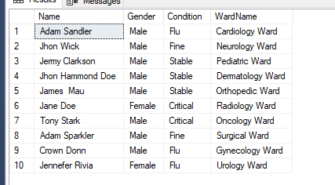

Select Name, Gender, Condition, Date_Checked_In, WardName, WardType

from Patients

Full join Wards

on Patients.PatientID = Wards.WardID

